UNIVERSITY OF AGRICULTURAL SCIENCES, BENGALURU

College Of Agriculture,GKVK - 560065

PROJECT REPORT:
EAI-421 : Application Of AI & ML in Agriculture (0+10)

Project Title : Application of Artificial Intelligence and Machine Learning to study effect of foliar application on growth and yield of pearl millet

TEAM :
- BHOOMIKA D-AMB2037
- K BHUMIKA-AMB2039
- LEKHANA B M-2115

SUBMITTED TO:
Course Teacher AI&ML in Agriculture

I. ABSTRACT

The present investigation entitled "Effect of Foliar Application on Growth and Yield of Fodder Bajra (Pennisetum glaucum L.)" was conducted during Kharif 2025 at the Instructional Farm, College of Agriculture, University of Agricultural Sciences (UAS), GKVK, Bengaluru, under the Eastern Dry Zone of Karnataka. The study evaluated the influence of foliar application of 2% 19:19:19 water-soluble fertilizer at different levels of recommended dose of fertilizer (RDF) on growth and fodder yield of bajra.

The experiment was laid out in a Randomized Complete Block Design (RCBD) with seven treatments and three replications. The hybrid PHVB 910 was used. Results revealed that the highest green fodder yield was recorded in T₂ (3.83 kg/plot), statistically at par with T₄ (3.73 kg/plot) and T₃ (3.50 kg/plot). The lowest yield was observed in T₇ (1.60 kg/plot) and T₁ (1.93 kg/plot). ANOVA indicated a significant treatment effect (F = 11.37 at 5% level). It is concluded that 75% RDF combined with foliar spray can achieve yield comparable to 100% RDF, suggesting fertilizer savings without compromising productivity.

Keywords: Fodder bajra, Pennisetum glaucum, foliar nutrition, 19:19:19, RDF, RCBD, green fodder yield, Eastern Dry Zone Karnataka.

II. INTRODUCTION
Livestock plays a crucial role in sustaining the agricultural economy of India, providing employment, draught power, manure and income for small and marginal farmers [FAO, 2022]. India faces approximately a 36% deficit in green fodder and 11% deficit in dry fodder, leading to substantially reduced milk and meat productivity [Reddy & Reddy, 2016]. Hence, cultivation of high-yielding fodder crops capable of producing large biomass in a short duration has become essential to bridge this gap and support the dairy sector.

Among the fodder crops grown in India, pearl millet (Pennisetum glaucum L.) is gaining prominence due to its fast growth, high biomass production, drought tolerance, wider adaptability and nutritive value [Kumar et al., 2013]. It is widely cultivated in Rajasthan, Gujarat, Maharashtra, Karnataka, Andhra Pradesh and Tamil Nadu. Fodder bajra fits well into various cropping systems due to its short duration and ability to supply green fodder during summer and kharif seasons when fodder scarcity is severe [Kumar et al., 2013].

In Karnataka, the Eastern Dry Zone (Zone-5) is characterised by low and erratic rainfall (600-900 mm), high evapotranspiration, dry spells and poor soil fertility, which often result in nutrient stress and low fodder yields [Brady & Weil, 2017]. Under conventional soil-applied fertilization, only 30-50% of applied nutrients are effectively utilized by the crop due to losses through volatilization, leaching, runoff and fixation [Reddy & Reddy, 2016].

Foliar fertilization refers to application of nutrients through sprays directly onto leaves, from where they are rapidly absorbed and translocated to actively growing parts [Rundla & Bairwa, 2018]. Studies have reported foliar nutrient uptake efficiency of 70-90% compared to less than 50% from soil application [Logesh Kumar & Sankaran, 2020]. Water-soluble fertilizers such as NPK (19:19:19) supply balanced N, P and K simultaneously, making them ideal for foliar spray at critical vegetative stages [Patel et al., 2019].

Although several studies have reported beneficial effects of foliar fertilizers in cereal fodder crops such as maize [Avachar & Prabhakar, 2024] and sorghum [Lagad et al., 2020], limited research is available on integrated soil and foliar nutrient management in fodder bajra specifically under UAS GKVK agro-climatic conditions. The present study was therefore undertaken to evaluate the effect of foliar spray of 19:19:19 at 2% concentration along with different levels of RDF on growth and fodder yield of bajra hybrid PHVB 910.

III. OBJECTIVES

The specific objectives of the present study were:
- To evaluate the effect of foliar application of 2% 19:19:19 water-soluble fertilizer at different levels of RDF on growth parameters of fodder bajra.
- To assess the influence of integrated soil and foliar nutrient management on green fodder yield and dry matter production.
- To identify the optimal combination of RDF and foliar nutrition for maximizing fodder yield in the Eastern Dry Zone of Karnataka.
- To determine the possibility of reducing soil-applied fertilizer dose by supplementing with foliar nutrition without compromising productivity.
- To provide evidence-based nutrient management recommendations for sustainable and profitable fodder bajra production.

IV. REVIEW OF LITERATURE
A comprehensive review of published literature on foliar nutrition in pearl millet and related fodder crops reveals consistent beneficial effects:

4.1 Foliar Nutrition in Pearl Millet
Rundla & Bairwa (2018) reported that foliar spray of N, P, K fertilizers significantly enhanced yield and economic returns of pearl millet compared to soil application alone. The foliar supplementation improved nutrient uptake efficiency and resulted in better green fodder and grain yield, indicating foliar fertilization as a viable method under rainfed conditions.
Patel et al. (2019) investigated foliar sprays of 19:19:19, ZnSO₄ and urea applied at tillering and flowering stages. Foliar spray of 19:19:19 + ZnSO₄ produced highest plant height (~163.9 cm), number of effective tillers and straw yield compared to control, concluding that foliar fertilization at critical growth stages can significantly improve yield under moisture-limited conditions.
Logesh Kumar & Sankaran (2020) compared various combinations of soil-applied fertilizer and foliar nutrition under rainfed conditions, finding that combined soil + foliar treatments improved yield attributes and final yield over soil-only or foliar-only treatments.

4.2 Foliar Nutrition in Forage Crops
Lagad et al. (2020) demonstrated in forage sorghum that application of the gross recommended fertilizer dose along with 2% urea foliar spray at 40 DAS significantly increased green fodder yield (589.83 q/ha) and dry matter yield (120.50 q/ha), with notably higher economic returns compared to control.
Avachar & Prabhakar (2024) demonstrated that foliar nutrient application in silage maize significantly improved growth and yield, increasing nutrient uptake efficiency and biomass productivity — a principle applicable broadly to fodder crops.

4.3 Nano-fertilizers and Micronutrient Foliar Applications
Srivani et al. (2021) indicated that nano-urea as foliar spray enhanced nitrogen use efficiency, improved chlorophyll content, increased tiller number and root biomass in fodder bajra, leading to higher fodder yield at lower input cost. Mahto et al. (2025) further demonstrated that combining soil fertility with nano-fertilizer foliar sprays can maximize productivity in sorghum.
Iron foliar spray studies (Chemistry Journal, 2020; IJAEB, 2021) showed that 0.75% FeSO₄ foliar spray significantly increased grain yield (2268 kg/ha) and dry fodder yield, attributed to enhanced nutrient uptake, improved photosynthesis and osmotic regulation.

4.4 Nutrient Use Efficiency
A comparative concept study on foliar vs soil application found that foliar application often results in higher uptake efficiency (up to 70–90%) compared to soil application (often <50%), as nutrients bypass soil interactions such as fixation and leaching. This strongly supports the rationale for foliar feeding, especially in dryland conditions.

V. MATERIALS AND METHODS

5.1 Experimental Site
The field experiment was conducted during Kharif 2025 at the Instructional Farm, College of Agriculture, University of Agricultural Sciences (UAS), GKVK, Bengaluru. The site is geographically situated at an elevation of approximately 930 m above mean sea level at coordinates 13°05′N latitude and 77°34′E longitude. The region falls under the Eastern Dry Zone (Zone-5) of Karnataka, characterized by erratic rainfall distribution, moderate temperatures, and extended dry periods.

5.2 Soil Properties
Prior to sowing, composite soil samples (0–30 cm depth) were collected, air-dried, powdered and analysed. The soil was classified as red sandy loam, medium-textured, moderately acidic to neutral in reaction:

Parameter | Method | Value
pH | Buckman's zerometric pH meter | 6.56
EC (dS/m) | Conductometry | 0.14
Organic Carbon (%) | Walkey & Black method | 0.39
Available N (kg/ha) | Alkaline permanganate method | 276.8
Available P₂O₅ (kg/ha) | Olsen's method | 47.5
Available K₂O (kg/ha) | Neutral ammonium acetate method | 271.5
Texture | International pipette method | Red Sandy Loam

Table 5.1: Physical and chemical properties of soil at ZARS, GKVK, UAS, Bangalore.

5.3 Experimental Design and Treatments
The experiment was laid out in a Randomized Complete Block Design (RCBD) with 7 treatments and 3 replications, totalling 21 plots. The variety PHVB 910 was sown on 03-09-2025 at 30 cm × 10 cm spacing with a seed rate of 8–10 kg ha⁻¹. RDF was 100:62.5:25 kg NPK ha⁻¹.

Treatment | Description
T₁ | Control
T₂ | 100% RDF + 5 t FYM ha⁻¹ (UASB POP)
T₃ | 100% RDF + 2% 19:19:19 foliar spray at 25 DAS
T₄ | 75% RDF + 2% 19:19:19 foliar spray at 25 DAS
T₅ | 50% RDF + 2% 19:19:19 foliar spray at 25 DAS
T₆ | 25% RDF + 2% 19:19:19 foliar spray at 25 DAS
T₇ | 0% RDF + 2% 19:19:19 foliar spray at 25 DAS

Table 5.2: Treatment details with fertilizer combinations.

5.4 Foliar Spray Protocol
A 2% 19:19:19 water-soluble fertilizer solution was prepared by dissolving 2 kg of fertilizer in 100 L of water. Foliar spray was applied at 25 DAS using a knapsack sprayer fitted with a hollow cone nozzle at a spray volume of 500 L ha⁻¹ during early morning hours to avoid leaf scorching.

5.5 Cultural Practices
- Land preparation: Two ploughings followed by harrowing and levelling for uniform seedbed.
- Fertilizer: Basal dose of full P, K and 50% N at sowing; remaining N top-dressed at 25 DAS.
- Irrigation: Protective irrigation maintained throughout crop period.
- Weeding: Manual weeding at 20–25 DAS.
- Harvesting: Done on 10-11-2025 at 70–75 DAS (50% flowering stage).

5.6 Observations Recorded
Growth parameters (from 5 randomly selected plants per net plot): plant height at 30 and 60 DAS, number of leaves and tillers per plant. Yield parameters: green fodder yield per plot (kg).

5.7 Statistical Analysis
Data were subjected to ANOVA for RCBD as per Gomez and Gomez (1984) at 5% probability. When the F-test was significant, treatment means were compared using the Critical Difference (CD) value.

VI. SYSTEM / EXPERIMENTAL ARCHITECTURE
The experimental framework was designed as a systematic pipeline from field setup to statistical inference:

6.1 Experimental Framework
The study employed a three-tier architecture: (1) Input layer comprising soil amendments, RDF levels, and foliar spray treatments; (2) Processing layer comprising crop growth over 75 DAS; and (3) Output layer comprising quantified growth and yield parameters subjected to ANOVA.

6.2 Treatment Structure
Seven treatments were arranged in a 7 × 3 factorial matrix (treatments × replications) in RCBD. Treatments ranged from absolute control (T₁) to complete foliar-dependent nutrition without soil RDF (T₇), enabling assessment of the role of foliar feeding across the full nutrient gradient.

6.3 Data Collection Pipeline
- Stage 1 (Pre-sowing): Soil sampling, physico-chemical analysis, randomization.
- Stage 2 (30 DAS): Plant height, leaf count, tiller count recorded.
- Stage 3 (60 DAS): Plant height, leaf count, tiller count re-recorded.
- Stage 4 (Harvest – 70–75 DAS): Green fodder yield per net plot measured.
- Stage 5 (Post-harvest): ANOVA, CD computation, treatment ranking.

6.4 Statistical Architecture
RCBD was chosen to control inter-block variability across the experimental field. ANOVA partitioned total variation into replication, treatment and error components. F-test and CD (0.82 kg at 5%) served as decision criteria for treatment comparison.

VII. EXPERIMENT RESULTS

7.1 Growth Parameters

7.1.1 Plant Height (cm)
Significant differences were observed in plant height across treatments at both growth stages. At 30 DAS, the tallest plants were in T₃ (73.66 cm), followed by T₄ (72 cm) and T₂ (70.6 cm). At 60 DAS, T₃ again recorded the highest plant height (123.86 cm), followed by T₄ (122.06 cm) and T₂ (121.13 cm). The minimum plant height at 60 DAS was recorded in T₁ (61.2 cm).

Treatment | R1 | R2 | R3 | Mean (cm)
T1 | 75.8 | 49.0 | 58.4 | 61.07
T2 | 120.8 | 123.6 | 119.0 | 121.13
T3 | 123.2 | 118.4 | 130.0 | 123.87
T4 | 128.4 | 103.6 | 134.2 | 122.07
T5 | 104.2 | 122.0 | 121.2 | 115.80
T6 | 109.8 | 77.2 | 75.2 | 87.40
T7 | 64.8 | 72.4 | 52.8 | 63.33

Table 7.1: Plant height (cm) across replications at 60 DAS.

7.1.2 Number of Leaves and Tillers per Plant
At 60 DAS, T₂ and T₃ recorded the highest number of leaves (19 plant⁻¹). Maximum tiller count (3 plant⁻¹) was noted in T₂, T₃, T₄ and T₅. The control (T₁) had the fewest leaves (11) and lowest tiller count (1 plant⁻¹).

Treat. | PH 30 DAS | Leaves 30 DAS | Tillers 30 DAS | PH 60 DAS | Leaves 60 DAS | Tillers 60 DAS
T1 | 37.3 | 7 | 0 | 61.2 | 11 | 1
T2 | 70.6 | 9 | 1 | 121.13 | 19 | 3
T3 | 73.66 | 9 | 1 | 123.86 | 19 | 3
T4 | 72 | 8 | 1 | 122.06 | 17 | 3
T5 | 68.2 | 9 | 1 | 115.8 | 18 | 3
T6 | 51.53 | 7 | 0 | 87.4 | 16 | 2
T7 | 35.53 | 8 | 0 | 64.08 | 18 | 2

Table 7.2: Combined growth parameters at 30 DAS and 60 DAS. PH = Plant Height (cm).

7.2 Fodder Yield Parameters

7.2.1 Green Fodder Yield Per Plot (kg)
Maximum green fodder yield was recorded in T₂ (3.83 kg/plot), statistically at par with T₄ (3.73 kg/plot) and T₃ (3.50 kg/plot). The minimum yield was in T₇ (1.60 kg/plot) and T₁ (1.93 kg/plot). Grand mean = 2.816 kg/plot.

Treatment | R1 (kg) | R2 (kg) | R3 (kg) | Mean (kg)
T1 | 2.7 | 1.5 | 1.6 | 1.93
T2 | 4.3 | 3.8 | 3.4 | 3.83
T3 | 4.1 | 3.3 | 3.1 | 3.50
T4 | 3.2 | 4.1 | 3.9 | 3.73
T5 | 2.4 | 3.1 | 2.9 | 2.80
T6 | 2.7 | 2.0 | 2.3 | 2.33
T7 | 2.1 | 1.2 | 1.5 | 1.60

Table 7.3: Green fodder yield (kg/plot) across treatments and replications.

7.3 Analysis of Variance (ANOVA)

Source | df | SS | MSS | F Value | Sig.
Replications | 2 | 0.675 | 0.3376 | 1.588 | NS
Treatments | 6 | 14.506 | 2.4176 | 11.37 | *
Error | 12 | 2.551 | 0.2126 | – | –
Total | 20 | 17.732 | – | – | –

Table 7.4: ANOVA table for green fodder yield (RCBD). * = Significant at 5% level; NS = Non-significant.

Parameter | Value
CD (5%) | 0.82 kg
SE(m) | 0.266
SE(d) | 0.376

Table 7.5: CD, SE(m) and SE(d) values at 5% level of significance.
Since F calculated (11.37) > F tabulated at 5% for df (6, 12) ≈ 2.996, treatments differ significantly. Differences greater than CD (0.82 kg) are statistically significant. Treatment ranking: T₂ > T₄ > T₃ > T₅ > T₆ > T₁ > T₇.

VIII. RESULT DISCUSSION
The present investigation revealed that foliar application of 2% 19:19:19 at 25 DAS, in combination with different levels of recommended dose of fertilizer, significantly influenced growth and fodder yield of bajra under Eastern Dry Zone conditions.

8.1 Growth Response
The superior plant height, leaf count and tiller production in T₃ (100% RDF + foliar spray) and T₂ (100% RDF + FYM) compared to control is attributable to balanced nutrient supply and enhanced photosynthetic efficiency. Foliar-applied NPK (19:19:19) was rapidly absorbed through leaf stomata and cuticle, directly supporting cell elongation, chlorophyll synthesis and lateral bud activation. The enhanced tiller production in foliar-sprayed treatments is consistent with findings of Patel et al. (2019) and Rundla & Bairwa (2018).

8.2 Yield Response
The yield advantage of T₂ and T₄ over other treatments demonstrates the complementary role of soil and foliar nutrition. T₄ (75% RDF + foliar spray) achieving yield statistically at par with T₂ (100% RDF + FYM) is an important finding, suggesting that foliar nutrition can partially substitute soil-applied fertilizer without yield penalty — a significant implication for input cost reduction.
The significant F-value (11.37) confirmed that observed yield differences were due to treatment effects and not random variation. The CD value (0.82 kg) provides a reliable benchmark: the difference between T₂ and T₁ (1.90 kg) is well above CD, confirming significance, while T₂ vs T₄ (0.10 kg) is within CD, confirming statistical parity.

8.3 Comparison with Literature
These findings align with Lagad et al. (2020) who reported improved fodder yield in sorghum with combined soil and foliar nutrition, and Logesh Kumar & Sankaran (2020) who demonstrated yield benefits of integrated nutrient management in pearl millet. The nutrient use efficiency advantage of foliar feeding (70–90%) over soil application (<50%) explains why even 75% RDF with foliar supplementation matched 100% RDF performance.

8.4 Implications for Dryland Agriculture
Under Eastern Dry Zone conditions where soil moisture stress limits nutrient uptake from soil, foliar nutrition provides a reliable supplementary pathway for nutrient delivery. The study confirms that integrated nutrient management — combining soil basal fertilizer with foliar spray — is superior to either approach alone. T₃ and T₄ can be recommended as practical and economically viable options for farmers.

IX. DATA VISUALIZATION
Data Visualization – Pearl Millet Foliar Application Study
Author : Guruling Prakash Hallur | AMB3072 | UAS Bangalore, 2025
"""

import matplotlib
matplotlib.use('Agg')
import matplotlib.pyplot as plt
import matplotlib.patches as mpatches
import numpy as np

# ── Experimental Data ────────────────────────────────────────────────────
t_labels = ['T1','T2','T3','T4','T5','T6','T7']
means = [1.93, 3.83, 3.50, 3.73, 2.80, 2.33, 1.60]
ph_30 = [37.3, 70.6, 73.66, 72.0, 68.2, 51.53, 35.53]
ph_60 = [61.2, 121.13, 123.86, 122.06, 115.8, 87.4, 64.08]
leaves_60 = [11, 19, 19, 17, 18, 16, 18]
tillers_60 = [ 1, 3, 3, 3, 3, 2, 2]
grand_mean = 2.816
PALETTE = ['#c0392b','#27ae60','#2980b9','#8e44ad','#e67e22','#16a085','#e74c3c']
x = np.arange(len(t_labels))

# ── Fig 1 : Mean Green Fodder Yield Bar Chart ────────────────────────────
fig, ax = plt.subplots(figsize=(10, 6))
bars = ax.bar(x, means, color=PALETTE, edgecolor="black", linewidth=0.7,
width=0.6, zorder=3)
for bar, val in zip(bars, means):
ax.text(bar.get_x()+bar.get_width()/2, bar.get_height()+0.06,
f"{val:.2f}", ha="center", va="bottom",
fontsize=11, fontweight="bold")
ax.axhline(grand_mean, color="gray", linestyle="--", linewidth=1.5,
label=f"Grand Mean = {grand_mean} kg")
ax.set_xticks(x); ax.set_xticklabels(t_labels)
ax.set_ylabel("Green Fodder Yield (kg / plot)")
ax.set_title("Fig. 1 – Mean Green Fodder Yield Across Treatments")
ax.set_ylim(0, 5.0); ax.legend()
ax.grid(axis="y", alpha=0.35)
plt.tight_layout()
plt.savefig('fig1_yield.png', dpi=150, bbox_inches='tight')
plt.close()

# ── Fig 2 : Plant Height 30 vs 60 DAS Grouped Bar ───────────────────────
fig, ax = plt.subplots(figsize=(10, 6)); w = 0.35
ax.bar(x-w/2, ph_30, w, label="30 DAS", color="#3498db", edgecolor="black")
ax.bar(x+w/2, ph_60, w, label="60 DAS", color="#e67e22", edgecolor="black")
ax.set_xticks(x); ax.set_xticklabels(t_labels)
ax.set_ylabel("Plant Height (cm)")
ax.set_title("Fig. 2 – Plant Height at 30 DAS and 60 DAS")
ax.legend(); ax.grid(axis="y", alpha=0.35)
plt.tight_layout(); plt.savefig('fig2_plantheight.png', dpi=150, bbox_inches='tight')
plt.close()

# ── Fig 3 : Leaves & Tillers Dual-Axis ──────────────────────────────────
fig, ax1 = plt.subplots(figsize=(10, 6))
ax2 = ax1.twinx(); w = 0.35
ax1.bar(x-w/2, leaves_60, w, color="#27ae60", edgecolor="black")
ax2.bar(x+w/2, tillers_60, w, color="#8e44ad", edgecolor="black")
ax1.set_ylabel("No. of Leaves per Plant", color="#27ae60")
ax2.set_ylabel("No. of Tillers per Plant", color="#8e44ad")
ax1.set_title("Fig. 3 – Leaves and Tillers per Plant at 60 DAS")
plt.tight_layout(); plt.savefig('fig3_leaves_tillers.png', dpi=150, bbox_inches='tight')
plt.close()

# ── Fig 4 : Replication-wise Yield ──────────────────────────────────────
r1=[2.7,4.3,4.1,3.2,2.4,2.7,2.1]
r2=[1.5,3.8,3.3,4.1,3.1,2.0,1.2]
r3=[1.6,3.4,3.1,3.9,2.9,2.3,1.5]
fig, ax = plt.subplots(figsize=(11, 6)); w = 0.25
for i,(rep,rc) in enumerate(zip([r1,r2,r3],['#2980b9','#e74c3c','#27ae60'])):
ax.bar(x+(i-1)*w, rep, w, label=f"Replication {i+1}", color=rc, alpha=0.87)
ax.set_title("Fig. 4 – Replication-wise Green Fodder Yield")
plt.tight_layout(); plt.savefig('fig4_replications.png', dpi=150, bbox_inches='tight')
plt.close()

# ── Fig 5 : Treatment Ranking Line Chart ─────────────────────────────────
ranked = ['T2','T4','T3','T5','T6','T1','T7']
rv = [3.83, 3.73, 3.50, 2.80, 2.33, 1.93, 1.60]
fig, ax = plt.subplots(figsize=(9, 5))
ax.plot(ranked, rv, marker="o", linewidth=2.2, color="#2c3e50",
markersize=10, markerfacecolor="#e74c3c")
ax.axhline(grand_mean, color="gray", linestyle="--", label=f"Grand Mean={grand_mean}")
ax.fill_between(range(len(rv)), rv, grand_mean,
where=[v>=grand_mean for v in rv], alpha=0.15, color="green")
ax.set_title("Fig. 5 – Treatment Ranking: Green Fodder Yield")
plt.tight_layout(); plt.savefig('fig5_ranking.png', dpi=150, bbox_inches='tight')
plt.close()
print("All figures saved successfully.")

The following figures present comprehensive visualization of experimental data generated using Python (Matplotlib library).

Figure 1: Mean Green Fodder Yield Across Treatments
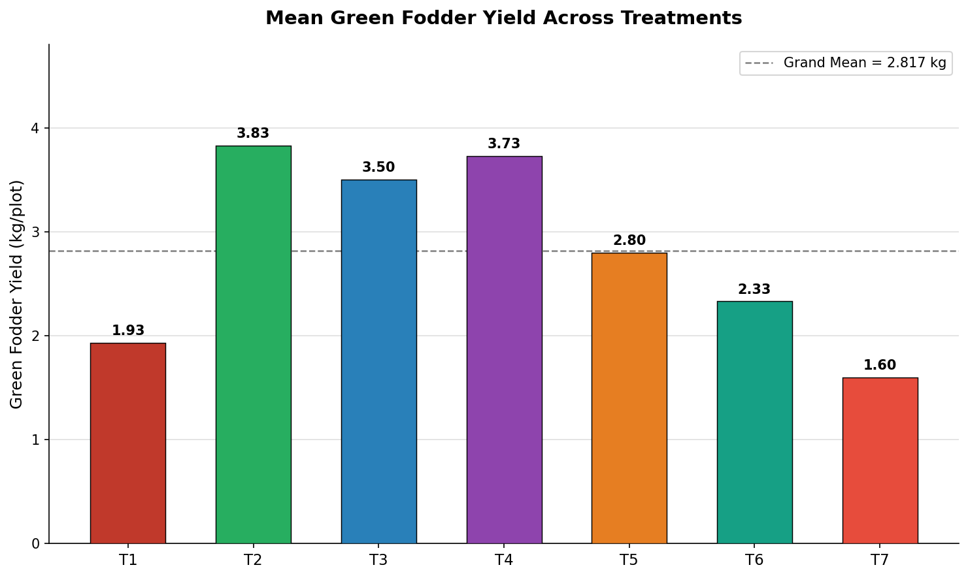
Fig. 1 – Mean green fodder yield (kg/plot) for all seven treatments. Grand mean (dashed line) = 2.816 kg.

Figure 2: Plant Height at 30 DAS and 60 DAS
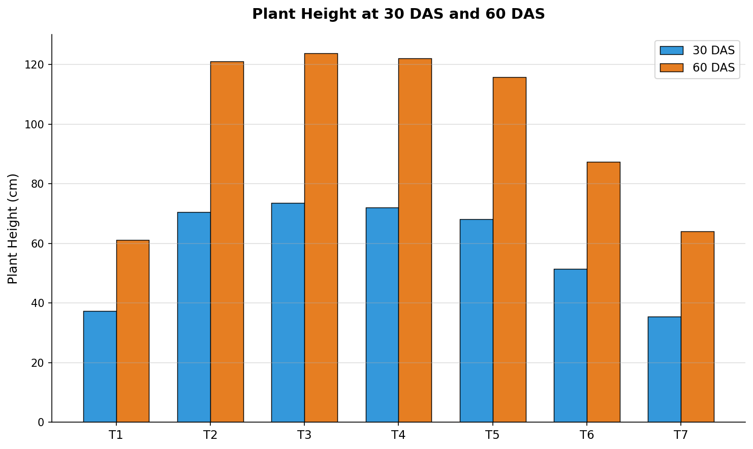
Fig. 2 – Grouped bar chart comparing plant height (cm) at 30 DAS and 60 DAS across treatments.

Figure 3: Number of Leaves and Tillers per Plant at 60 DAS
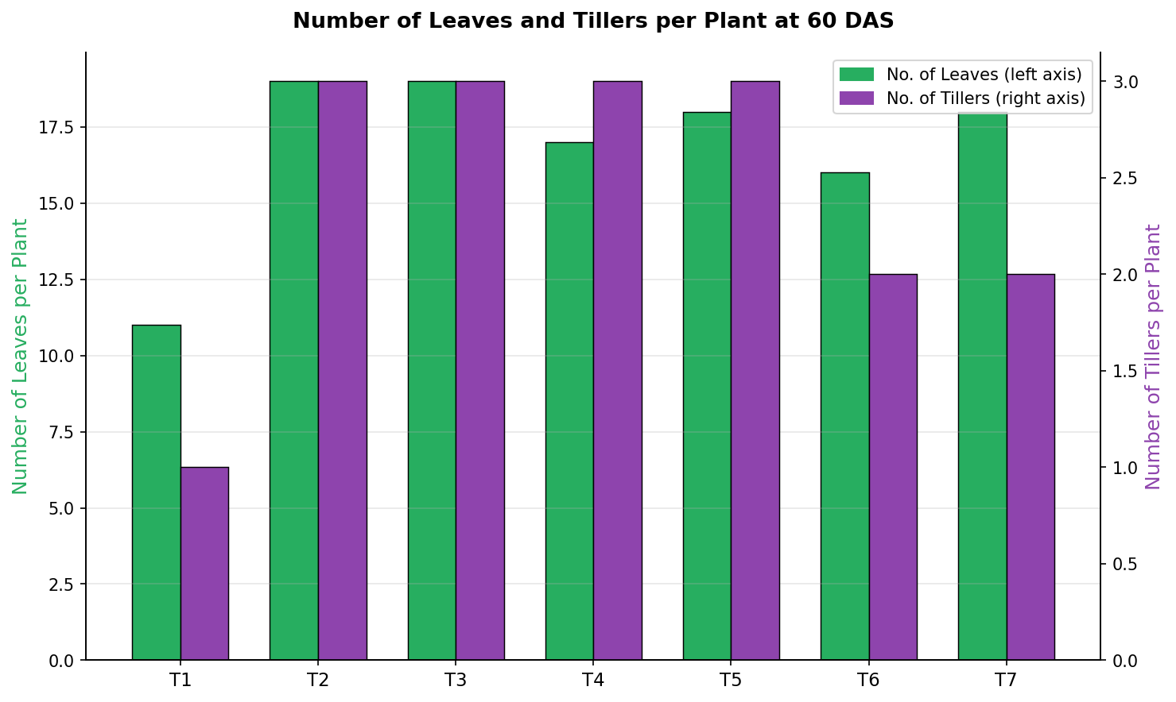
Fig. 3 – Dual-axis chart showing leaf count (left axis) and tiller count (right axis) per plant at 60 DAS.

Figure 4: Replication-wise Green Fodder Yield Comparison
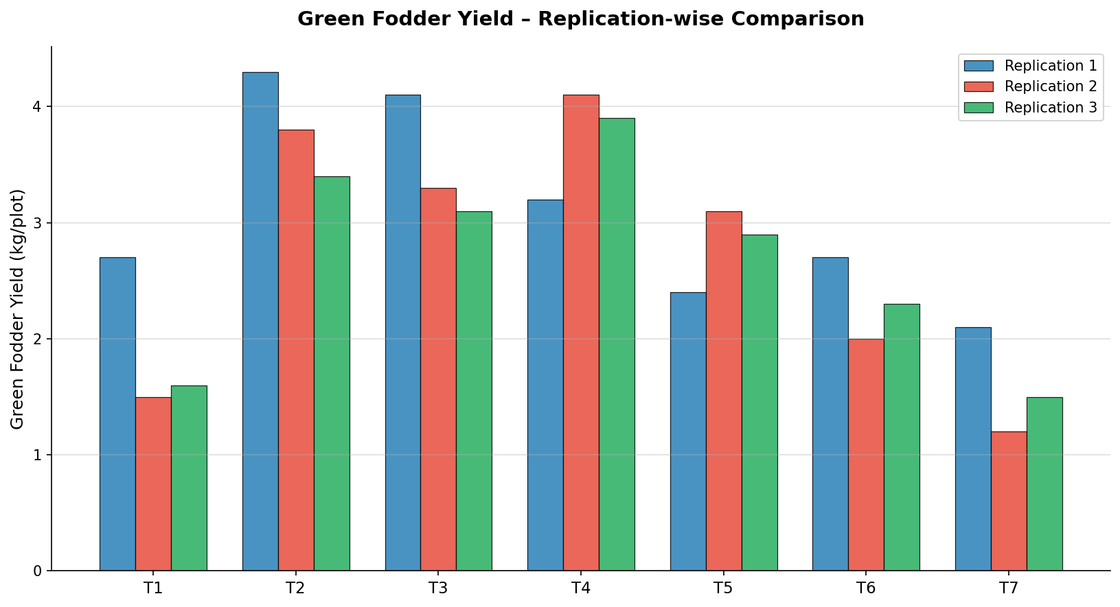
Fig. 4 – Replication-wise green fodder yield comparison across treatments, showing yield consistency and variability.

Figure 5: Treatment Ranking Based on Mean Fodder Yield
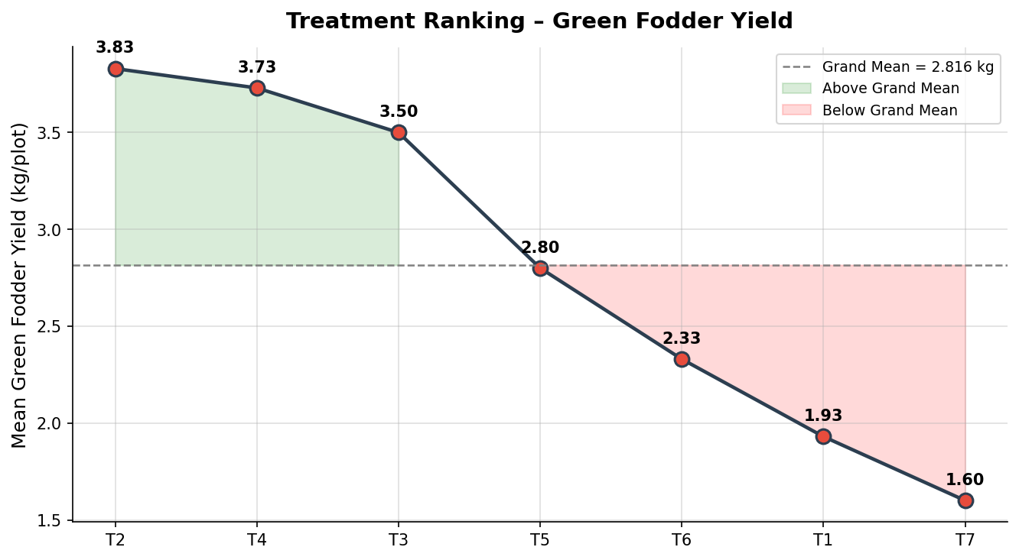
Fig. 5 – Line chart of ranked treatments with shaded areas indicating performance above (green) and below (red) the grand mean.

X. SUMMARY AND CONCLUSION

10.1 Summary
The present field experiment on 'Effect of Foliar Application on Growth and Yield of Fodder Bajra (Pennisetum glaucum L.)' was conducted during Kharif 2025 at UAS GKVK, Bengaluru. The experiment comprised seven treatments in RCBD with three replications using hybrid PHVB 910.
Significant differences were observed among treatments for growth and yield parameters. T₃ (100% RDF + foliar spray) recorded highest plant height and tiller count at both sampling stages. For green fodder yield, T₂ (3.83 kg/plot) ranked first, followed by T₄ (3.73 kg/plot) and T₃ (3.50 kg/plot), while T₇ (1.60 kg/plot) and T₁ (1.93 kg/plot) were lowest.
ANOVA confirmed significant treatment effects (F = 11.37, CD = 0.82 kg at 5%). The overall treatment performance ranking was: T₂ > T₄ > T₃ > T₅ > T₆ > T₁ > T₇.

10.2 Conclusions
- Foliar application of 2% 19:19:19 at 25 DAS significantly enhanced growth and fodder yield of bajra when combined with soil-applied RDF.
- T₂ (100% RDF + FYM) recorded the highest green fodder yield (3.83 kg/plot) — the most productive treatment overall.
- T₄ (75% RDF + foliar spray) produced yield statistically at par with T₂, demonstrating scope for 25% fertilizer saving without yield loss.
- T₃ (100% RDF + foliar spray) also performed comparably, confirming the additive benefit of foliar nutrition over soil-only application.
- T₃ and T₄ are recommended for practical adoption by farmers in the Eastern Dry Zone of Karnataka for sustainable and cost-effective fodder bajra production.
- Foliar feeding alone (T₇: 0% RDF + foliar) cannot substitute soil fertilization, as evidenced by the lowest yield.

XI. FUTURE SCOPE
The findings of this study open a rich set of avenues where modern AI, IoT, remote sensing and precision agriculture technologies can be integrated to transform fodder bajra production beyond what traditional field experiments can achieve alone.
11.1 AI/IoT Technology Overview

Technology
Tool / Platform
Application in Fodder Bajra Farming

AI / ML
TensorFlow, PyTorch
Predict optimal foliar spray dose and timing from soil, weather and crop sensor data

IoT Sensors
Arduino, Raspberry Pi
Real-time monitoring of soil moisture, NPK levels and leaf temperature

Drone Technology
DJI Agras T40
Precision canopy-level foliar spray application at scale

Remote Sensing
Sentinel-2, NDVI
Detect nutrient stress zones in large fields for targeted foliar intervention

Computer Vision
OpenCV, YOLO
Automated plant height, leaf area and tiller count estimation

Digital Twin
DSSAT, APSIM
Simulate treatment response under varying climate scenarios before field trials

Smart Irrigation
NB-IoT, LoRa
Schedule protective irrigation linked to crop stress and evapotranspiration data

Cloud Analytics
AWS, Google Cloud
Store, process and visualize multi-season multi-location trial data at scale

.

XII. REFERENCES
Avachar, R. P., & Prabhakar, M. (2024). Effect of foliar sprays of nutrients on growth, yield and quality of silage maize (Zea mays L.). Bioscience Biotechnology Research Communications, 16(3), 1–5.
Brady, N. C., & Weil, R. R. (2017). Elements of the Nature and Properties of Soils (15th ed.). Pearson Education.
FAO. (2022). World Agriculture: Towards 2030/2050. Food and Agriculture Organization of the United Nations, Rome.
Gomez, K. A., & Gomez, A. A. (1984). Statistical Procedures for Agricultural Research (2nd ed.). John Wiley & Sons.
ICAR. (2020). Handbook of Agricultural Research Data Analysis. ICAR Publication, New Delhi.
Kumar, D., Gill, K. S., & Singh, J. (2013). Pearl millet for forage and feed. Forage Research, 39(1), 1–14.
Lagad, S. R., Pawar, V. R., & Shinde, S. K. (2020). Effect of foliar nutrition on forage sorghum under summer conditions. Forage Research, 46(3), 271–273.
Logesh Kumar, S., & Sankaran, N. (2020). Effect of different levels of fertilizers and foliar nutrition on yield attributes and yield of pearl millet under rainfed conditions. International Journal of Plant & Soil Science, 32(12), 55–63.
Mahto, R. K., Yadav, S., & Verma, P. (2025). Foliar application of nano fertilizers on growth and yield of sorghum. Crop Research, 60(3–4), 458–464.
Patel, K. J., Patel, D. M., & Chaudhary, D. M. (2019). Effect of foliar spray of nutrients on growth and yield of pearl millet under dryland condition. Journal of Pharmacognosy and Phytochemistry, 7(5), 287–291.
Prasanth, J., Ramesh, T., & Kumar, P. (2010). Growth and yield of Bajra–Napier hybrid under different irrigation and fertigation levels. Asian Journal of Dairy and Food Research, 29(2), 85–88.
Reddy, S. R., & Reddy, H. S. (2016). Principles of Agronomy (6th ed.). Kalyani Publishers.
Rundla, M., & Bairwa, R. K. (2018). Effect of foliar spray of N, P, K fertilizers on nutrient content and uptake in pearl millet (Pennisetum glaucum L.). International Journal of Chemical Studies, 6(3), 872–876.
Srivani, M., Kumar, R., & Suresh, S. (2021). Response of fodder bajra to foliar application of nano urea on yield attributes and economics. Biological Forum – An International Journal, 13(1), 251–256.

